PROC SQL Black Belt Techniques for SAS Professionals
(SAS 9.4 M9 Edition)
Experienced SAS developers know that PROC SQL can serve as much more than a query language. At an advanced level, it becomes a powerful tool for dynamic programming, performance optimization, and metadata-driven automation.
This guide presents five “black belt” PROC SQL techniques frequently used by senior SAS developers when building scalable and automated SAS solutions.
All examples use SASHELP datasets so they can be executed in any SAS environment.

1. Dynamic SQL Code Generation
One powerful pattern is using PROC SQL to generate SAS code dynamically based on metadata.

Example: Generate a PROC MEANS statement dynamically
proc sql noprint;
select name
into :numvars separated by ' '
from dictionary.columns
where libname='SASHELP'
and memname='CLASS'
and type='num';
quit;

proc means data=sashelp.class;
var &numvars;
run;

Macro Variable Generated
&numvars = Age Height Weight

Example Output (PROC MEANS)

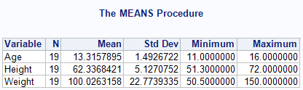

Why this is powerful
- Automatically adapts to schema changes
- Eliminates manual variable lists
- Essential in large ETL frameworks

2. Multi-Table Summary Using Inline Views
Inline views allow you to build layered SQL logic inside a single query.

Example: Average Weight by Age

proc sql;
select age, avg_weight
from
(select age,
avg(weight) as avg_weight
from sashelp.class
group by age) as summary
order by avg_weight desc;
quit;

Example Output

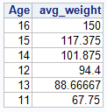

Why this is powerful
- Enables multi-stage transformations
- Simplifies complex reporting queries
- Reduces intermediate datasets

3. Efficient De-duplication with DISTINCT and GROUP BY
Advanced SQL developers use controlled aggregation rather than sorting to identify duplicates.

Example
proc sql;
select distinct age
from sashelp.class;
quit;

Example Output

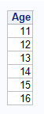

Alternative Duplicate Frequency Check
proc sql;
select age,
count(*) as freq
from sashelp.class
group by age;
quit;

Example Output

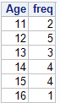

Why this matters
- Helps detect data anomalies
- Common in data quality pipelines

4. SQL-Based Table Creation for Fast Data Transformation
PROC SQL allows fast table creation with filtering and derived columns.

Example
proc sql;
create table class_bmi as
select name,
age,
weight/(height*height)*703 as bmi
from sashelp.class;
quit;

Example Output

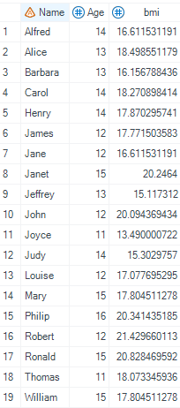

Why this is powerful
- Combines transformation and table creation
- Eliminates DATA step overhead
- Common in data marts and staging layers

5. SQL Performance Optimization Using WHERE vs HAVING
Advanced developers understand that WHERE filtering occurs before aggregation, while HAVING filters after aggregation.

Example
proc sql;
select age,
avg(weight) as avg_weight
from sashelp.class
where age >= 13
group by age;
quit;

Example Output

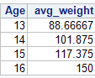

Why this matters
Clause | When Applied
WHERE | Before grouping
HAVING | After aggregation
Using WHERE whenever possible improves performance, especially for large datasets.

Key Takeaways
Advance PROC SQL developers treat SQL as a programming framework inside SAS, not just a query language.
These advanced techniques enable:
Technique | Benefit
Dynamic SQL generation | Self-configuring SAS programs
Inline views | Complex transformations without intermediate datasets
Aggregation patterns | Efficient data quality checks
SQL table creation | Simplified ETL logic
Query optimization | Improved performance

